10/5/2012

|  |
| --- |
| Version 1.0 | Spang |

|  |  |
| --- | --- |
| Spang | System Architecture |

Table of Contents

Introduction 2

System architecture 2

Android (client) architecture 2

Computer (server) architecture 2

Connection between client and server 2

Motivated larger design choices 2

Sensor refactoring 2012-10-10 2

Network refactoring 2012-10-12. 3

Before Refactoring 5

After Refactoring 9

Touch handling refactoring 12

# Introduction

The Spang API is an API designed to facilitate the sending of sensor input from an android device to a computer. The API provides an interface for encoding and sending the input on the android side, as well as an interface for decoding the input, generating sensor events, on the computer side.

# System architecture

## Android (client) architecture

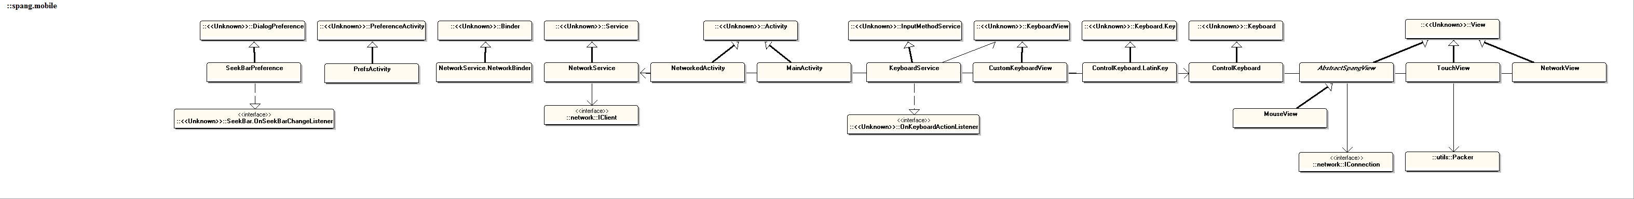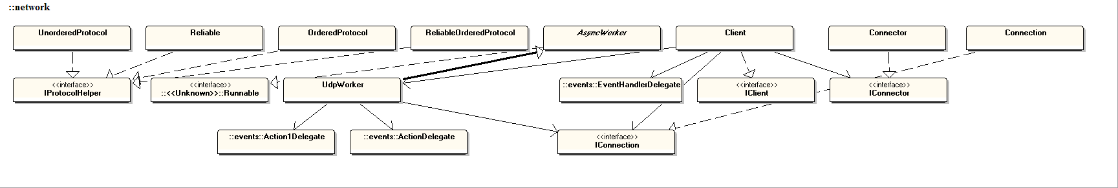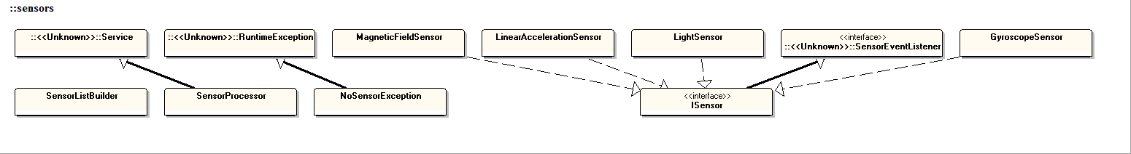

## Computer (server) architecture

## Connection between client and server

# Motivated larger design choices

## Sensor refactoring 2012-10-10

We refactored the way we implemented sensors in Spang. Instead of having one class (implementing ISensor) per sensor we decided to have a SpangSensor class (implementing ISensor) that can represent an arbitrary sensor using instance variables.

Because of this refactoring, a lot of lines of code were lost. It was no great loss though, since most of those lines were duplicated in each sensor class anyway.

The original reason for not designing this way in the first place is the fear for not being able to freely customize the methods for specific sensors, but this can still be achieved by creating a single customized sensor class (see OrientationSensor)

#### What changed?

The following classes where deleted:

And the following classes were added:

Instead of creating an entire new class in order to add a new sensor, one must simply create a new instance of a SpangSensor object in the SensorList builder class:

**if**(**this**.manager.getDefaultSensor(Sensor.*TYPE_GRAVITY*)!=**null**)

sensorBindings.put(Sensor.*TYPE_GRAVITY*, **new** SpangSensor(manager, Sensor.*TYPE_GRAVITY*, (**byte**) resources.getInteger(R.integer.*Gravity*)));

Note that the above code is still not as clean as one might which, but that it still is a lot cleaner than before this refactoring.

## Network refactoring 2012-10-12.

#### What changed?

A simple serialization API was introduced. This API serializes messages before they are sent over the connection. And deserializes received message. The following types were affected by the change.

The following classes where changed:

And the following classes were added:

#### Reason:

The end user had to interact with byte arrays as messages. That has worked so far in the project only through lots of trial and error.

Sending was not that hard (if you remembered to add the correct id before each message and pack as byte and not float etc.), but receiving was both error prone and annoying.

Furthermore, debugging was a problem since the code used for sending was scattered all over the place. The Serialization API solves most of these problems.

### Before Refactoring

#### Usage: (End User)

**public** **void** sendTouchEvents(TouchEvent event) {

//Packers help pack data into byte arrays.

Packer packer = **new** Packer();

//Packs the ID so that the reciving end knows that this is a touch event.

packer.packByte((**byte**)R.integer.TouchID);

//Packs the number of touches currently down on the android device.

packer.packByte((**byte**)event.Touches.Length);

**for**(**int** i = 0; i < event.Touches.Length;i++) {

//Packs location and pressure for each touch.

packer.packShort((**short**)event.Touches[i].getX());

packer.packShort((**short**)event.Touches[i].getY());

packer.packByte((**byte**)(event.Touches[i].getPressure() * 256.0f));

}

//Sends the packed data through the NetworkService.

**this**.network.send(packer.getPackedData(), Protocol.Reliable);

}

**public** **void** addListeners() {

**this**.client.addRecivedListeners(**new** Action1<**byte**[]>() {

**public** **void** onAction(**byte**[] message) {

UnPacker unpacker = **new** UnPacker(message);

**while**(unpacker.remaining() > 0) {

//Gets the id of the message.

**int** id = unpacker.unpackByte();

**if**(id == TOUCH_ID) {

//Decode the touch event.

TouchEvent event = decodeTouchEvent(unpacker);

//Use the event for something.

**this**.updateTouchStateMachine(event);

} **else** **if**(id == SOME_OTHER_MESSAGE_ID)

//Decode some other message.

SomeOtherMessage message = decodeSomeOtherMessage(unpacker);

//Use the message somehow.

**this**.useMessage(message);

}

//...More else if

}

}

};

}

Remarks: As can be seen receiving messages are annoying since you must both decode them and use them for something. The code above contains no sorts of error checking so if encounters unexpected messages if will just crash.

To add a new type of message, all that had to be done was to take a new Unique ID pack it before the message and then pack the contents of the message.

**public** **void** sendMyNewCoolMessage(CoolMessage message){

Packer packer = **new** Packer();

//Pack ID

packer.packByte((**byte**)R.integer.cool_message);

//Pack contents of message.

packer.packInt(message.someIntVar);

packer.packString(message.someStringVar);

**this**.network.send(packer.getPackedMessage(), Protocol.Ordered);

}

**public** **void** addListeners() {

**this**.client.addRecivedListeners(**new** Action1<**byte**[]>() {

**public** **void** onAction(**byte**[] message) {

UnPacker unpacker = **new** UnPacker(message);

**while**(unpacker.remaining() > 0) {

**int** id = unpacker.unpackByte();

//...Recive alot of messages.

} **else** **if**(id == COOL_MESSAGE_ID) {

//Decode the cool message.

CoolMessage message = **this**.decodeCoolMessage(unpacker);

//Do cool stuff with the message.

**this**.doCoolStuff(message);

}

}

}

};

}

Remarks: The largest problem with this approach is that new messages cannot even be added to code that you do not control and if you need to receive data in multiple locations the IDs the decode code and needs to be distributed to all the locations.

Another problem is that you need to know that the id is 1 byte long and the first item in a message. This is by far too low level for anyone getting started with the API.

### After Refactoring

**public** **void** sendTouchEvents(TouchEvent event) {

//Sends the event.

**this**.network.send(event, Protocol.Reliable);

}

**public** **void** addListeners() {

**this**.client.addRecivedListeners(**new** Action1<**byte**[]>() {

**public** **void** onAction(Object message) {

**if**(message **instanceof** TouchEvent) {

//Use the touch event for something.

**this**.updateTouchStateMachine((TouchEvent)message);

} **else** **if**(message **instanceof** SomeOtherMessage) {

//Use the message somehow.

**this**.useMessage((SomeOtherMessage)message);

}

}

}

};

}

Remarks: The Receiving code is a lot simpler to follow. We still use if else statements to know the type of the data, but we no longer need to decode them ourselves.

First we create a class that can serialize and deserialize the message.

**public** **class** CoolMessageSerializer **extends** Serializer<CoolMessage>{

**public** Class<?> getSerializableType() {

**return** CoolMessage.**class**;

}

**public** **void** serializeInternal(Packer packer, CoolMessage message)

{

//Pack contents of message.

packer.packInt(message.someIntVar);

packer.packString(message.someStringVar);

}

**public** SensorEvent deserialize(UnPacker unpacker)

{

**int** id = unpacker.unpackInt();

String string = unpacker.unpackString();

**return** **new** CoolMessage(id, string);

}

}

**public** **void** someMethod() {

//If we are on the client side.

**this**.client.registerSerializer(**new** SomeOtherSerializer());

**this**.client.registerSerializer(**new** CoolMessageSerializer());

//If we are on the server side.

**this**.server.registerSerializer(**new** SomeOtherSerializer());

**this**.server.registerSerializer(**new** CoolMessageSerializer());

}

Remarks: At the time of this writing the order in which the serializers are added is EXTREMLY IMPORTANT since the order they are added decides their ID. This is still subject to change.

Now the new message is ready to be received and send over the network. To use the new message simply add another else if statement in the receiving message listener checking for the CoolMessage type.

## Touch handling refactoring

Instead of handling the users touch events in the Android application code; we decided to move the implementation to the PC server.

The idea was to simplify API usage for Android developers, and to provide a standard way of interpreting touch input on the PC side.

After the refactoring, the only thing an Android developer needs to write to control the mouse is a View sending all TouchEvents (in the onTouchEvent method) using a NetworkService. This makes the View code more focused on the actual visuals, instead of getting filled with hundreds of rows of confusing mouse control logic.

Another consequence of this refactoring is that a developer who wants to create a custom way of handling touches sent from an Android device now does this in the PC application.

We definitely prefer this approach, since the Android device should only be responsible for sending input (like a regular mouse sends input to a computer through an USB cable). The PC application then interprets and acts based on said input.